OPEN SECTION - FRUIT
Class 1101–One Champagne Watermelon.
Class 1102–One Long Watermelon.
Class 1103–One Round Watermelon.
Class 1104-One Rockmelon.
Class 1105–Melon, any other variety (to be named).
Best Melon of Show $5.00 *1101-1105
Class 1106-Four Tomatoes – Red Round.
Class 1107-Four Tomatoes – Egg Shape.
Class 1108-Six Tomatoes – Cherry.
Class 1109-Four Tomatoes – any other variety.
Best Tomato of Show $5 *classes 1106-1109
Class 1110-Any other Fruit to be name.
Class 1111-SPECIAL CLASS – Best collection of. Old Fashion, rare or Exotic fruit & Vegetable
Exhibitor card to include varieties.

OPEN SECTION - VEGETABLE
Class 1112-Three Carrots (with tops attached).
Class 1113-Three Beetroot (with tops attached
Class 1114-Six Radishes (with tops attached).
Class 1115-Twelve Beans (any variety).
Class 1116-Silverbeet – two stalks.
Class 1117-One Lettuce – any variety.
Class 1118-Two Cobs of Sweetcorn-in the husk
Class 1119-Four Potatoes-any variety.
Class 1120-Two Sweet Potatoes.
Class 1121-Two Cucumbers – long.
Class 1122-Two Cucumbers – apple.
Class 1123-Collection of Squash.
Class 1124-Four Onions (with tops attached).
Class 1125-Three Garlic Bulbs.
Class 1126 -Herbs – Any variety (Fresh or Dried
Class 1127-Any other Vegetable – to be named

GIANT FRUIT OR VEGETABLE
Exhibitor Card Must Indicate Fruit Variety
Class 1128-Tomatoes & Watermelon will be judge as Fruit. Each entry to be accompanied with details of how the plant was grown.
1st $15.00, 2nd $10.00, 3rd $5.00.

POTTED PRODUCE
Class 1129-Any variety of Fruit, Vegetable or Herb (can include a mixture) grown in a pot.

PUMPKINS
Class 1130-One Qld. Blue Pumpkin.
Class 1131-One Kent Pumpkin.
Class 1132-One Butternut Pumpkin.
Class 1133 One Jarrahdale Pumpkin.
Class 1134- Any Heirloom Pumpkin or Grammas. Class 1135-Collection of pumpkins (not less than 3 varieties).
Class 1136-Heaviest Table Pumpkin * all table pumpkins from classes 1130-1135 can also be nominated for this class.
Champion Pumpkin $10.00 & Ribbon
Reserve Champion Pumpkin $5.00 &Ribbon
Class 1137-Scarecrow, Open from 13 years & over -any material, min height 60cm “Circus Magic Theme”.
Class 1138-Scarecrow, Junior 12 years & under-any material, min height 60cm “Circus Magic Theme”.
EGG CLASSES
Class 1139-Six Large White Hen Eggs.
Class 1140-Six Large Brown Hen Eggs.
Class 1141-Six Large AOC Hen Eggs.
Class 1142-Six Bantam White Eggs.
Class 1143-Six Bantam Brown Eggs.
Class 1144-Six Bantam AOC Eggs.
Class 1145-Twelve Hen eggs judged on weight (no double yokes) include a note of their diet to achieve this. Class 1146-Six -Any Other Varity (e.g. duck, turkey, guineafowl, quail).
Class 1147-Basket of Eggs, 1 dozen, mixed colour, variety, presentation.
Champion Eggs $10.00 Plus Ribbon
Reserve Champion Eggs $5.00 plus Ribbon

JUNIOR HOME-GROWN GARDEN
Age to be written on the back of exhibitor card
Class 1148- 9-12 years – Salad Bowl, create a collection of fruit, vegetable, herbs (not cut) not less than 3 varieties, to be arranged in a salad Bowl.
Class 1149- 9-12 years -Vegetable Sculpture, using mainly fruit & vegetable theme “Circus Magic Theme”.
Class 1150- 9-12 years – Tomato Plant in a decorated pot, any variety, grown in a 20cm pot, staked.

JUNIOR HOME-GROWN GARDEN PRIZES

Champion 9-12 years Trophy plus Ribbon
Reserve Champion 9-12 years $5.00 plus
Ribbon
Champion 4-8 years Trophy plus Ribbon
Reserve Champion 4-8 years $5.00 plus Ribbon
Encouragement Award Junior Home-Grown Garden $10.00 – Donated by Pittsworth Show Fruit & Vegetable Stewards

SCHOOL SECTION – No Entry Fee
Class 1157- Fruit & Vegetable Display
A Box 60cm Wide x 1 meter in Height to be elevated for display. This is a display of local produce. To be Judged on *Quality of produce *Effective use of produce *Originality of design*Arrangement of exhibit.

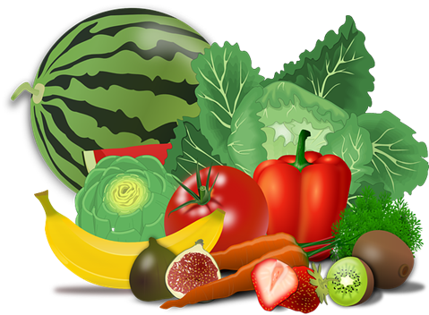

JUNIOR HOME-GROWN GARDEN
Age be written on the back of exhibitor card
Class 1151- 4-8 years – Basket of Produce, create a beautiful basket of fruit, vegetable, herbs, not less than 3 varieties in a suitable sized carry basket. Filling, decorations, accessories allowed.
Class 1152- 4-8 years - Vegetable Sculpture, using mainly fruit & vegetable theme
“Circus Magic Themer”.
Class 1153-4-8 years – Grow a Carrot Top – using a shallow dish with damp cotton wool, put your carrot top on and watch it grow. This will need to be started at least three weeks before the show.

HIGH SCHOOL
Class 1154-From My Vegie Patch – A collection will be set up on displace shelves. Not less than three varieties.
Class 1155-Pizza Herb Hanging Garden.
Class 1156-D.I.Y. Bee & Butterfly water station
Include a A4 Poster “Raising Why Bees Matter”

Champion High School Trophy plus Ribbon

Reserve Champion $5.00 plus Ribbon

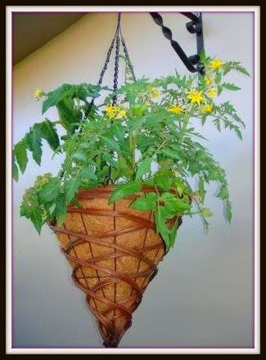
This Photo by Unknown Author is licensed under CC BY-ND

