DOG SHOW & PET PARADE
Steward – Jen Pierson
Saturday 6th March on the Village Green commencing at 9.30am No Entry Fee - Entries taken at 9am on the day. Handlers must be at least 13 years of age.
All competitors must pay entry to the grounds Prizes – Ribbon & Trophy
All dogs must be over 3 months of age, vaccinated, sociable and on leash.
DOG SHOW
- Small dog (less than 30cm at shoulder)
- Medium dog (30 to 50 cm at shoulder)
- Large dog (over 50 cm at shoulder)
- Junior dog (under 12 months)
- Senior dog (over 8 years)
- Shiny dog
- Working dog
- Obedient dog
- Grand Champion Dog of the Show – chosen from 1st place winners
PET PARADE – Will follow Dog Show
No Entry Fee -Enter on the day. All pets must be on a leash or in a cage Children handling pets must be at least 5 years old and accompanied by an adult.
Do not bring pets that will be frightened by noise or other animals.
All competitors must pay entry to the grounds Prize - Ribbons & Trophy

- Cute pet
- Fluffy pet
- Small pet
- Big pet
- Clever pet
- Pet/owner look alike
- Grand Champion Pet of the Show – chosen from 1st place winners
We Thank Sponsor’s Dayzee Lane - Champion Dog & Pet will receive a Pet Portrait
Creative Canines - Trophies
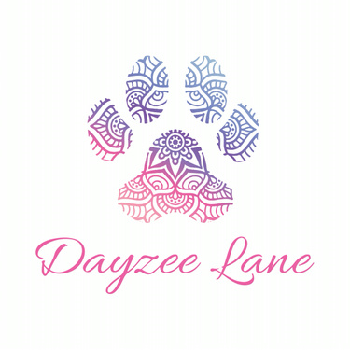
Dayzee Lane Pet Hub Pet Stylist and Grooming
Shop1 – 90A Yandilla Street Pittsworth QLD 4356 102 Yandilla St. Pittsworth Qld 4356
(07) 4550 4060 0437 924 897

