BUDGERIGARS
Class 9001 - GREEN, Light, Dark, Olive, Grey, Green.
Class 9002 - Sky Blue, Cobalt, Mauve, Violet, Grey.
Class 9003 - Lutino, Albino.
Class 9004 - Cinnamon Any Colour.
Class 9005 - Opaline Any Colour.
Class 9006 Pied (Dominant or Recessive).
Class 9007 – Spangle Any Colour.
Class 9008 – AOC and Non-Standardised Colour Varieties.
CHAMPION BUDGERIGAR - $20.00 voucher donated by Aquabird Pet Centre
CANARIES
Class 9009 – Border Fancy Any Colour. Class 9012 - Gloster Any Colour.
Class 9010 – Red Factor Any Colour. Class 9013 – Any Other Variety Canary.
Class 9011 – Fife Any Colour.
CHAMPION CANARY - $20.00 voucher donated by Aquabird Pet Centre
AUSTRALIAN FINCHES
Class 9014 – Zebra Pied. Class 9017 – Gouldian Any Colour.
Class 9015 – Zebra Any Other Colour. Class 9018 – Any Other Variety Australian Class 9016 – Double Bar. Finch.
CHAMPION AUSTRALIAN FINCH – Bag of Seed donated by Lovitt’s Group (QLD)
FOREIGN FINCHES
Class 9019 – Manikin Any Colour. Class 9022 – Nun Any Colour .
Class 9020 – Cut Throat. Class 9023 – Any Other Variety Foreign
Class 9021 – Java Any Colour. Finch.
CHAMPION FOREIGN FINCH – Bag of Seed donated by Lovitt’s Group (QLD)
LOVEBIRDS
Class 9024 –Peachface Green. Class 9028 – Lovebird/Peachface Any Other Colour.
Class 9025 –Peachface Yellow. Class 9029 – Any Other Australian Parrot.
Class 9026 - Peachface Any Other Colour. Class 9030 – Any Other Foreign Parrot.
Class 9027 –Fisher Any Colour.
CHAMPION LOVEBIRD $20.00 voucher donated by Aquabird Pet Centre
ANY OTHER VARIETY CAGED BIRD
Class - 9031 – Any Variety Dove. Class 9033 – Any Other Variety Caged Bird.
Class – 9032 – Any Variety Quail.
CHAMPION PARROT - $20.00 voucher donated by Aquabird Pet Centre
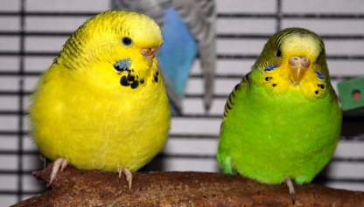
This Photo by Unknown Author is licensed under CC BY-SA

