Pittsworth Show 5th & 6th March 2021

Stud Beef Cattle Section

***Cattle Enquires – Bec Skene 0437 680 360, Wendy Pfeffer 0418 756 087***

Entries close Friday 26th February at 4pm

Cattle may not leave the show grounds until the completion of the Led Steer Judging Approx. 3pm. Loading Ramp Gates will be locked until judging is completed. (approximately 3.00pm)

Exhibitors are advised that the entry gate located on Factory Street (main entry to Cattle section) will be manned on Friday from 9am, Saturday from 5am. A one-day entry fee will be charged, and a two-day pass given to cattle exhibitors arriving on the FRIDAY. Admission prices: Adults $12, school children $5.00, children under 5 Free, for a two-day arm band. All admission fees payable in cash at the gate upon entry. Parking will be available for small vehicles on the grounds for camping.

*Prize Money will be available after the completion of led steer judging from the Prize Money Office,*

*NOTHING PRIOR WILL BE HANDED OUT*

**Cattle Classification for Showing at Pittsworth Show**

|  |  |  |  |
| --- | --- | --- | --- |
| **BRITISH** | **TROPICAL** | **EUROPEAN** | **SMALL BREEDS** |
| Angus | Belmont Red | Bazadaise | Ausline |
| Belted Galloway | Braford | Belgian Blue | Dexter |
| British White | Brahman | Blonde d’Aquitaine | Miniature Galloway |
| Devon | Brahmousin | Braunvieh | Miniature Hereford |
| Galloway | Brangus | Charolais | Lowline |
| Hereford | Charbray | Chiangus |  |
| Highland | Droughtmaster | Chianina |  |
| Lincoln Red | Greyman | Gelbvieh |  |
| Murray Grey | Santa Gertrudis | Limousin |  |
| Poll Hereford | Senepol | Maine-anjou |  |
| Red Angus | Simbrah | Mandalong Special |  |
| Red Poll |  | Piedmontese |  |
| Shorthorn |  | Pinzgauer |  |
| South Devon |  | Romagnola |  |
| Speckle Park |  | Salers |  |
| Square Meater |  | Simmental |  |



Cec Fox- 0418 721 100 Ben Fox – 0418 107 788

RULES

(Special Stud Beef, Prime Cattle Regulations at end of schedule also apply)

1. All cattle are eligible except those from restricted or quarantined herds

2. All cattle must comply with current NLIS regulations. Pittsworth Show Society Inc will read NLIS devices on Saturday 6th March 2021, at a time to be advised. Pittsworth Showgrounds PIC is: QEPW0235. An Owner waybill must accompany cattle.

3. The age of all cattle shall be actual age as at 1st March 2021.

4. All animals MUST be registered in a herd or calf register of the respective Breed Society and MUST be the bona fide property of the exhibitor. Checks of Breed Society registers will be made if necessary.

5. All animals MUST have a brand, either tattoo or fire.

6. All animals, which, in the opinion of the stewards, are not in a fit state to be exhibited, may be rejected and debarred from competition. Such animals must be removed from the grounds as soon as the exhibitor is notified.

7. In the event of the Judge deciding that the exhibit in any class or championship is not worthy of the prizes, NO prizes shall be awarded.

8. Any disputes arising, must be in writing and handed to the Recording Stewards for assessment by the Cattle Committee, within 30 minutes of the dispute, accompanied by the fee of $50. Refund of $50 will be given if dispute is upheld.

9. No refunds of entry fees given (exceptional circumstances may be considered within 7 days)

10. Dehorned cattle may compete in stud section if conditions are acceptable to their respective society.

11. Maximum age of calf to be shown as calf at foot to be 9 months. Calf at foot cannot be shown in separate class. However, calves under 9 months MAY compete in the 2021 Junior Bull Spectacular.

12. **All Cattle over four (4) months must have appropriate nose grips and all bulls over 12 months must have a nose ring. All stock MUST be in the charge of exhibitor or representative at all times.**

**Any animal over 4 months found not to have a nose ring will be disqualified and no refund of entries** **will be given. This is a safety issue.**

13. All exhibitors to have Public Liability Insurance and to have same endorsed for traveling to shows.

14. Any exhibitor/competitor intending to bring electrical equipment to the Showgrounds will be required to ensure that such equipment is fitted with residual current protection and that all electrical leads, tools and appliances have been inspected by a licensed electrical contractor and currently tagged. The use of double adaptors is prohibited, and all power boards must be tested and tagged. Clipping crates may only be placed on the grounds at the discretion of the Cattle Committee.

15. It is the responsibility of each exhibitor to ensure that the leaders of their stock in judging rings and parades are capable of exercising control over the animals in their care. Children under 12 years of age leading cattle in the Grand Parade MUST be accompanied by an adult over 18 years of age.

16. Exhibitors are invited to parade their cattle in the Grand Parade at 1pm. All cattle are welcome. Dress code applies. Cattle may not leave the show grounds until the completion of the Led Steer Judging Appro 3pm. Loading Ramps Gates with be locked until judging is completed. (approximately 3.00pm).

17. U/16-year old’s **MUST** have a supervisor with them at all times

18. Any alterations to entries may be accepted by the organisers and must be submitted to the **Chief Recorder prior to 7am Saturday.**

19. Strictly **no driving on ring area.**

20. Cattle are not to be unloaded after dark.

21. No Alcohol to be consumed outside of designated liquor permit area (ie – Bar)

22. Pittsworth Showgrounds has a strict NO DOGS ALLOWED policy unless dogs are part of competitions

Section 4B -YOUNG PARADERS COMPETITION

**Friday Evening 5 March 2021 - 3.00pm - Free Entry**

**A Young Paraders and Young Judges Form is attached and MUST be completed, along with Indemnity Waiver, prior to competitions.**

**E*ntry form to be submitted to Cattle Shed prior to 2.00pm***

**Age as of 1 May 2021** To be eligible to compete in Sub Chamber Competitors must be over 15 & under 25 years of age on 1 May 2021.

Competitors may parade the animal of their choice and may lead a steer, heifer or bull under 20 months.

Event judged on the ability of the competitor to handle, parade and present their particular beast for judging.

**Dress Standard**: School cattle Uniform, Dust Coats or Breed Society Uniform

Prize Money: 1st $20.00, 2nd $10.00, 3rd $5 if more than 4 in class

Class 4005 8 years and under

Class 4006 9 years & under 13 years

Class 4007 13 years & under 15 years

Class 4008 15 years & under 25 years (This class only eligible for Sub Chamber Finals)

***Champion Parader Awarded***

***Reserve Champion Parader Awarded***

***Thank you to our Trophy donor Ashton’s Butchery***

Section 4C – YOUNG JUDGES COMPETITION

**Friday Evening 5th March 2021 – 5.00pm – (or at completion of Paraders Competition. Free Entry**

A Young Paraders and Young Judges Form is attached and MUST be completed prior to competitions.

***Entry form to be submitted to Cattle Shed prior to 2.00pm***

Prize Money: 1st $20.00, 2nd $10.00, 3rd $5 if more than 4 in class

Class 4009 14 years & under

Class 4010 15 years & under 25 years (This class only eligible for Sub Chamber finals)

***Champion Young Judge***

***Reserve Champion Young Judge***

***Thank you to our Trophy donor Penleigh Brafords***

**CONDITIONS:**

1. Entries will be taken prior to 2.00pm on day of show.

2. Open to persons **under 25 years of age on 1st May 2021**, although only persons over 15 years of age are eligible for sub-Chamber competition.

3. No less than 4 animals of a prescribed breed & sex will be provided. Every effort will be made to use a different breed each year.

4. Each competitor will be provided with a card on which he or she will place the animals in their order of merit and give reasons for doing so. Upon completing the card, it will be handed to the Chief Steward for presentation to the judge, who may, if desired, question the competitor on any points in his judgment or any feature in connection with the cattle being judge.

5. The judge, in making the awards, shall take into consideration the correctness of placing the animals and reasons given. The Society will arrange for a competent person to demonstrate the points of the breed and explain their purpose in the general scheme of animal husbandry immediately after the cards are handed in.

Section 3 – STUD BEEF CATTLE

*Saturday 6thh March 2021 – JUNIOR BULL SPECTACULAR*

***Pittsworth Show Grounds – Pic No. QEPW0235***

***Breakfast available for purchase Saturday after 6am - $5.00***

Featuring the 2021 “RURAL STEEL SUPPLIES” Junior Interbreed Bull Spectacular

**Commencing 8.00am Sharp**

**Entry Fee $15.00**

***Prize Money 1st $75.00 – 2nd $50.00 – 3rd $20.00***

Class 4011 Under 9 moths

Class 4012 9 & under 12 months

Class 4013 12 & under 15 months

Class 4014 15 & under 18 months

Class 4015 18 & under 20 months

***Champion Junior Interbreed Bull***

***Reserve Champion Junior Interbreed Bull***

***Exhibitors are advised that the entry gate located on Factory Street (main entry to Cattle section) will be manned on Friday from 9am, Saturday from 5am. A one-day entry fee will be charged, and a two-day pass given to cattle exhibitors arriving on the FRIDAY. Admission prices: Adults $12, school children $5.00, children under 5 Free, for a two-day arm band. All admission fees payable in cash at the gate upon entry. Parking will be available for small vehicles on the grounds for camping.***

**Stalls are allocated. Exhibitors can view their stall allocations at the Cattle Shed from Friday 5th March 2021**

**Sawdust Bedding Supplied (part of your entry fee)**

**No Alcohol Allowed**

**No Dogs Allowed**

**Entries Close – Friday 26th February 2021 at 4pm**

**Entry Fee per Class: As per entry Form (Includes Sawdust Bedding)**

**Entries can be posted to P.O. Box 6, Pittsworth 4356**

**Email –** **pittsworthshowsecretary@gmail.com**

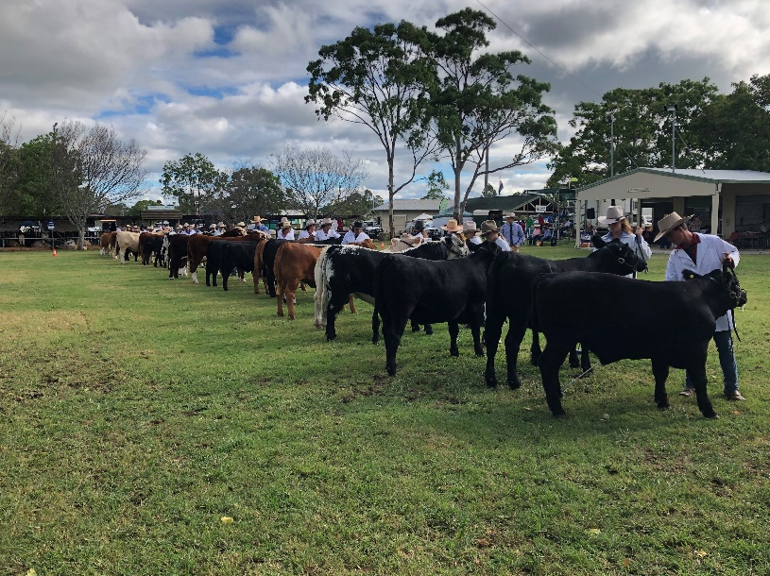

STUD BEEF CATTLE CLASSES

**All cattle to be on the grounds by 7.00am**

**Class Judging will commence Approx. 9.00am**

**Entry Fee $15.00**

Prize Money: 1st $20.00, 2nd $10.00, 3rd $5 if more than 4 in class

***All ribbons will be presented***

The age of all cattle shall be actual age as at 1 March 2021

Class 3000 - BULL ,6 months and Under 12 months

Class 3100 - BULL, 12 months and under 16 months

Class 3200 - BULL, 16 months and under 20 months

***Champion Junior Bull***

***Reserve Junior Champion Bull***

Class 3300 - BULL, 20 months and under 24 months

Class 3400 - BULL, 2 years and over

***Senior Champion Bull***

***Reserve Senior Champion Bull***

***Grand Champion Bull***

Class 3500 - FEMALE, 6 months and Under 12 months.

Class 3600 - FEMALE, 12 months and under 16 months

Class 3700 - FEMALE, 16 months and under 20 months

***Champion Junior Heifer***

***Reserve Champion Junior Heifer***

Class 3800 - FEMALE, 20 months and under 24 months

Class 3900 - FEMALE, 24 months and under 30 months

Class 3950 - FEMALE, 30 months and over

***Senior Champion Female***

***Reserve Senior Champion Female***

***Grand Champion Female***

***Group Classes***

Class 3998 - Interbreed Exhibitors Group – Fee $15

3 head with both sexes represented and owned and exhibited by the exhibitor

Class 3999 - Interbreed Sire or Dam Progeny Group – Fee $15

2 progeny of either sex sharing a common sire or Dam

***Supreme Bull of Show Supreme Female of Show***

***Judged from all of the breed Grand Champions***

 Section 4 - LED STEER OR HEIFER COMPETITION

***PLEASE NOTE CHANGE* - Weighing of steers/heifers will be between 7:00am-7:30am**

**Final allocation of classes will be made following weighing**

Saturday 6th March 2021 Judging will commence **1.30pm** sharp

Entries Close: Friday 26th February at 4pm 2021 Entry Fee: $15.00 includes GST

Prize Money: 1st $100.00; 2nd $75.00; 3rd $50.00

Classes with more than 10 entries, the following will be awarded:

4th $30.00; 5th $20.00; 6th $10.00 for Classes 1,2,3

***PLEASE NOTE:*** Heifers entered in these classes are not eligible for stud classes.

Competitors in this class must be milk tooth and will be mouthed if necessary.

**ALL ANIMALS MUST HAVE NOSE RINGS**

Class 4001 - Steer or Heifer – 350 kg and Under LIVEWEIGHT

Class 4002 - Steer or Heifer – 351 kg - 450 kg LIVEWEIGHT

***Champion Lightweight Steer - $100.00***

***Reserve Champion Lightweight Steer - $50.00***

Class 4003 - Steer or Heifer – 451 - 550 kg LIVEWEIGHT

Class 4004 - Steer or Heifer – 551kg and over LIVEWEIGHT

***Champion Heavyweight Steer - $100.00***

***Reserve Champion Heavyweight Steer - $50.00***

**Champion Led Steer /Heifer - $200.00**

**Reserve Champion Led Steer/Heifer - $100.00**

Thank You to our competitors, we would like to thank all generous sponsors, donations and trophy donors to the Cattle Section for the 2021 show. Also, the volunteers who contribute many valuable hours.

Grand Parade 1.00 pm

