Pittsworth Show Society Inc.
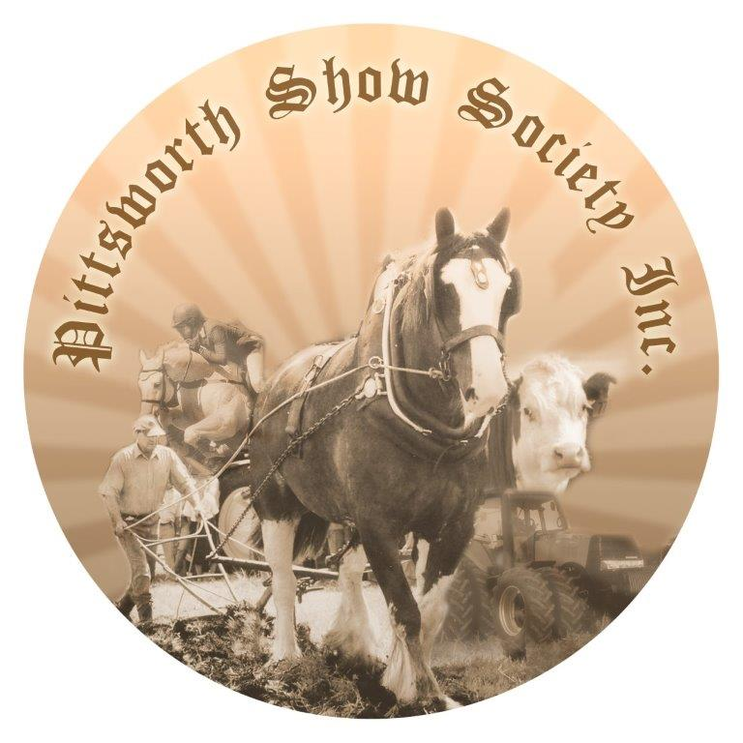
P.O. Box 6, Pittsworth Qld 4356
ABN: 25 361 214 043
Horse Stable Application Form
The Pittsworth Show Society Inc. has a limed number of stables available.
Preference will be given to competitors that do not live in the local area.
No Stallions allowed (QCAS regulations)
Applicants Details:
Name:

Address:

Suburb: | State: | P/code:
Phone Number:

Email:

Your Bank Detail for refund after inspection of stables… BSB: A/C No:

Stabling Details: $20 per stable for the duration of the show, $10.00 will be refunded after inspection of stable for cleanness.
Number of Horses: _____________ Gender of Horses: ______________
No. of Stables required: __________@ $20.00 Total to pay: $__________
Payment Details:
Payment for stables must be made in full with this application.
The Pittsworth Show Society Inc. will accept cash, cheque, money order or direct deposit
Please complete and return this form as soon as possible to avoid disappointment to
DIRECT DEPOSIT DETAILS
Account Name: Pittsworth Show Society Inc
BSB: 638 070
A/C No: 126 565 34
Reference: Stables & YOUR SURNAME
Email: amanda.riehl@outlook.com
Amanda Riehl
Mobile: 0439 856 403

